WEBSITE PLANNING & DOCUMENTATION REPORT

MMUSI DEALERSHIP WEBSITE PROJECT

- WEBSITE SPECIFICATIONS
The MMUSI Dealership website is a modern, luxury-focused automotive platform designed to showcase premium vehicles, particularly models from BMW, while providing users with an engaging and informative digital experience.
The website serves as an online showroom where customers can explore different car models, compare features, and learn about the latest automotive innovations. It highlights the dealership’s commitment to quality, performance, and luxury, aligning with the global reputation of BMW. They can also purchase a vehicle that caught their eyes.
In addition to showcasing vehicles, the website provides essential dealership services such as:
- Vehicle information and specifications
- Pricing and availability details
- Booking inquiries and test drive requests (future feature)
- Customer support and contact options
The platform is designed with a dark luxury theme, high-quality visuals, and a user-friendly interface to attract middle to high-income individuals who are interested in premium automotive experiences.
Overall, the website acts as a digital marketing and customer engagement tool, helping MMUSI Dealership build brand awareness, attract potential buyers, and maintain a professional online presence.

Objective:
The objective of this website is to promote the Mmusi dealership as a luxury automotive seller by showcasing vehicles, innovation, and services while engaging potential customers.
Goals:
- Increase brand awareness of BMW vehicles sold by the Mmusi dealership
- Provide information about car models
- Allow users to contact the company
- Collect user feedback
Target Audience:
- Demographics:
- Age: 25 – 55 years
- Gender: All
- Income Level: Middle to high-income earners
- Location: Global
Technical Aptitude:
- Familiar with online shopping and browsing
Type of Website:
- Corporate or Product showcase website
- Product Showcase
- Informational and interactive

2. INFORMATION DESIGN & TAXONOMY
SITE MAP STRUCTURE:
HOME
│
├── About Us
│ ├── Company Overview
│ └── Mission & Vision
│
├── Models
│ ├── First Car
│ ├── Second Car
│ ├── Third Car
│ ├── Fourth Car
│ ├── Fifth Car
│ └── Sixth Car
│
├── Contact Us
│ ├── Contact Form
│ ├── Location Map
│ └── Social Media Links
│
└── Feedback
└── Customer Reviews
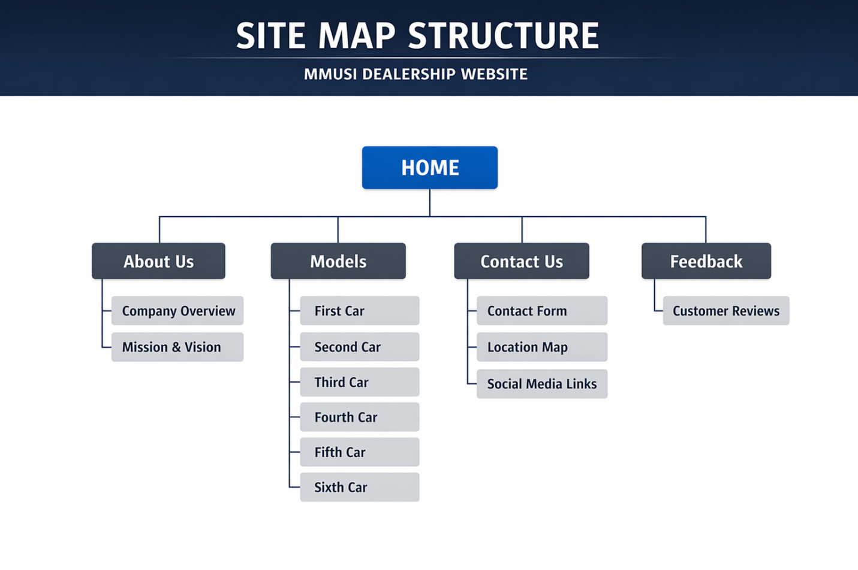

NAVIGATION FLOW:
Users can move between all pages using the navigation bar.
Max 3-click rule, ensuring easy access to all content.

3. PAGE TEMPLATE DESIGN
The website follows a consistent layout:
- Header (Navigation Bar)
- Hero Section (Image + Text)
- Content Sections
- Footer
Design Features:
- Dark luxury theme
- Large hero images
- Grid layout for models
- Clear spacing and alignment

4. TECHNICAL BRIEF
Technologies Used:
- HTML5: A standard language used to structure content on the website. It is also used to create web pages and embedding media.
- CSS3: A styling language used to design and format HTML content. It is also used for styling and layout, changing colors, fonts and spacing.
- Bootstrap: A front end framework with ready-made CSS and JavaScript components. Its also used for quickly building responsive websites, to add pre-designed elements.
- JavaScript: A programming language that adds interactivity to a web pages. Its used creating dynamic content, handling user actions, Fetching data from servers.

Tools Used:
- VS Code: A Lightweight but powerful code editor developed by Microsoft. Its used for writing and editing code, debugging programs, installing extensions for extra features.
- GitHub: A platform used for code hosting. Its used for storing and managing code online and deploying websites.
- Browser Development Tools: They are built in tools in browsers like Google Chrome or Mozilla Firefox for developers. Its used for testing the website, debugging JavaScript, inspecting and editing HTML/CSS live and monitoring performance and network activity.
- Pinterest: A visual discovery platform for ideas and inspection. Its used for retrieval of images used for the website, planning creative projects and saving design references.

5. QUALITY ASSURANCE
Testing Conducted:
- Browsers tested:
Google Chrome and Microsoft Edge
- Devices tested:
Desktop and Mobile view (responsive testing)
Results:
- Website displayed correctly across all browsers
- Responsive layout works on mobile devices

6. PUBLISHING & PROMOTION
Hosting Platform: GitHub Pages
Steps Used:
- Created repository
- Uploaded files
- Enabled GitHub Pages
Website Link Format:
THE MMUSI DEALERSHIP | Home

7. FUTURE DEVELOPMENTS
- Add car booking or test drive system
- Improve accessibility features

CONCLUSION
The MMUSI DEALERSHIP website successfully meets its objectives by providing a modern, responsive, and user-friendly platform for showcasing BMW products and engaging users.

